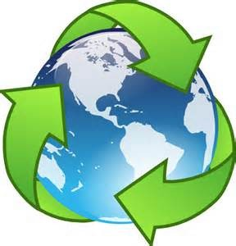RECYCLING PROJECT

Project Guidelines:

* Project is due on ____________________________. (If the project is turned in late, ____ points will be deducted each day after the due date)

# Project must be completed by the student with minimal assistance from parents.

* Students will receive two grades for this project.
  + Reflection - On the due date, students will complete a project reflection in class in which they will identify materials, procedure (steps), purpose of using recycled materials, and use of product.
  + Presentation - Students will present their product to the class and identify what materials they used. They will also explain how this product is useful.
* Below are some ideas to inspire you.

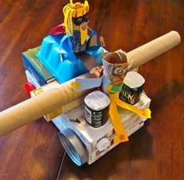 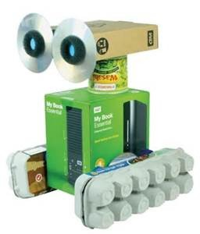 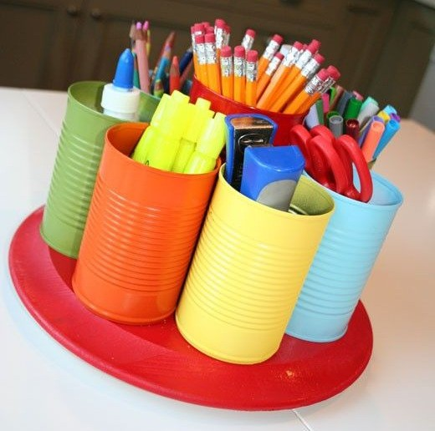 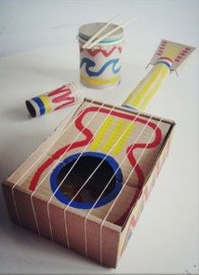

# Be creative and have fun! :)

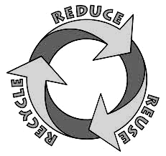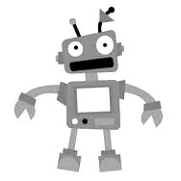Recycling Project Reflection

Plea

Please fill out the form below to show your reflection of your project!

Email this form and pictures of your project to your teacher!

Imagine you are going to sell your product at a store. What name would you give your product?

Product name: _____________________________________________________

1. What materials did you use to make your product?

 __________________________________

 __________________________________

 __________________________________

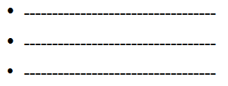 

Explain the steps you took to make your product (2 pts).

_______________________________________________________________________________________________________________________________________________________________________________________________

How did you come up with the idea for your product?

_______________________________________________________________________________________________________________________________________________________________________________________________

Is your project useful? What can it be used for?

___________________________________________________________________________________________________________________________